How to establish connectivity in ansible

How to establish connectivity in ansible

1.Create same user in master and slave nodes.

2.login Ansible master server through open ssh.

3.Search for hidden files(ls –la).

4.cat id_rsa.pub file and copy the key and should paste it in node servers.

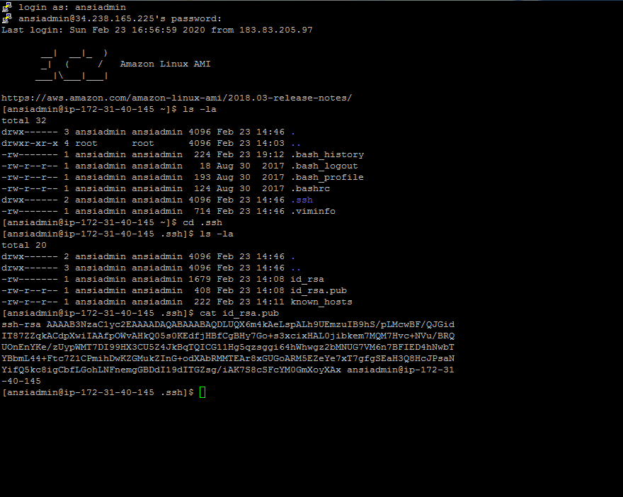

5.open node server ,create same username and password and then login.

6.create .ssh folder and authorized_keys file.

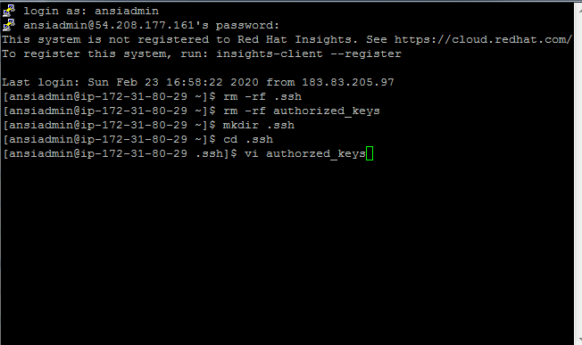

7.copy the key from ansimaster server to the node server.

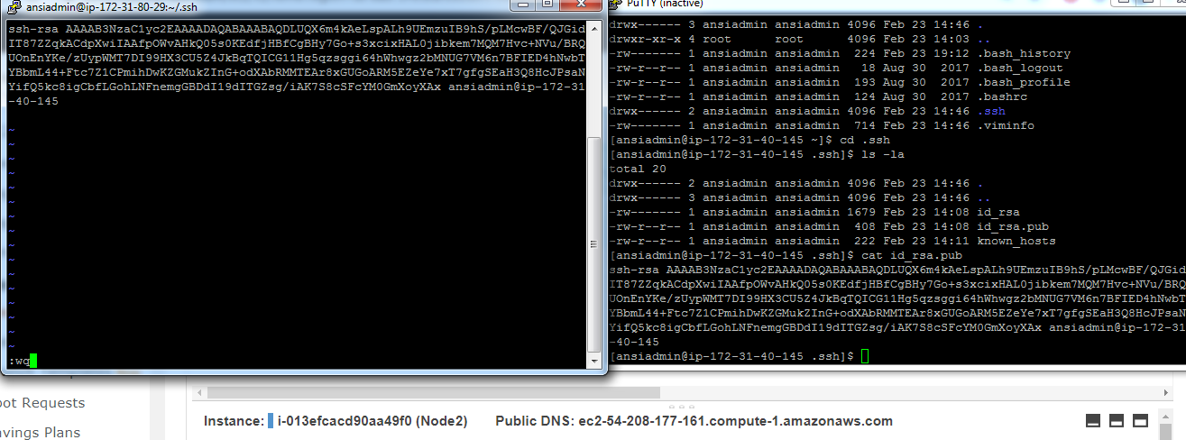

8.change permissions to .ssh and authorized_keys .

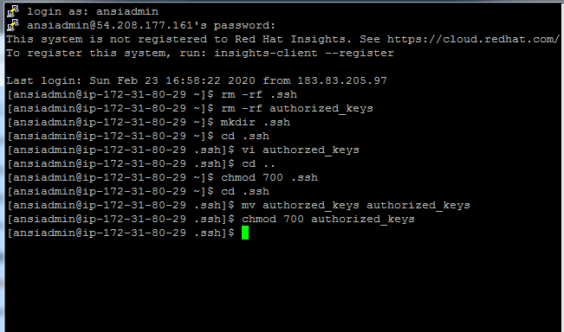

9.open Ansimaster server and enter ansiadmin@nodeip

10.the connection will establish.

